**WHAT’S IN THE FRIDGE?**



What’s in the fridge is an application where user inputs x number of ingredients found in the fridge and is provided with recipes for a fine breakfast, lunch or dinner. Application (via recipe API) will find recipes that encompass those ingredients with a visual on the side. User can save their recipes under a category (breakfast, lunch, dinner) and recall it when logging in again. List can be retrieved to determine meals for that day. Meals are also paired up with the perfect wine (from wine API)

**Git:** <https://github.com/nehasahay/Project2.git>

**Conceptual**

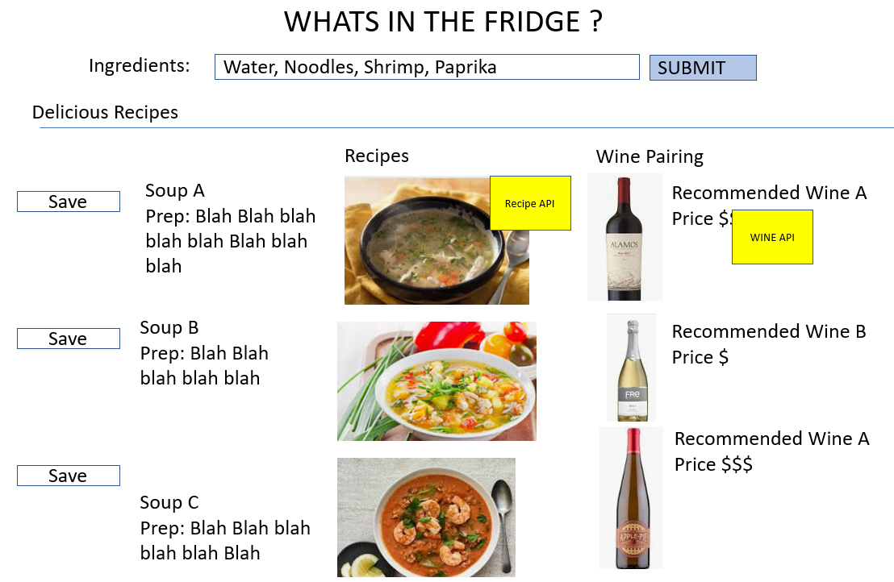

**Flow**

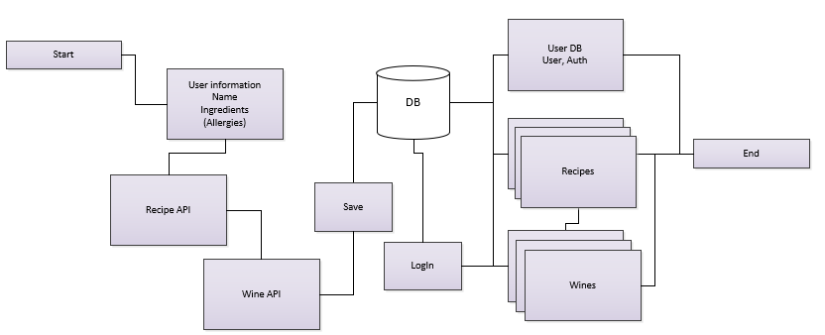

**User Form**

Name, Items in fridge

* Ingredient(s)

List of ingredients come up

* User can select from results to save under their profile
* User can categorize

**Return**

User logs into the application

* Saved list of ingredients
  + List of recipes
  + List of wines
  + When to dine on recipes

**API’s**

* **Recipes:** <https://developer.edamam.com/edamam-recipe-api>
* **Wine API:** <https://www.brewerydb.com/developers>

**DB:**

* MySQL (Local)
* Shark (Remote)

**Stretch**

* End user can add (to form) specific allergies
* List of ingredients returned will warn individual of allergen with link to WebMD..etc